 **Department of Computer**

**Science & Engineering**

*A Mini Project Report on*

**TecRidge: A platform for developers to develop their technical potential and inter-personal skills**

*Submitted in partial fulfillment of the requirements for the award of the degree of*

**Bachelor of Engineering in Computer Science & Engineering**

*By*

Abhishek S 1MS16CS004

K Sidhartha Nambiar 1MS16CS044

Keshava Pranath K 1MS16CS048

Lakshya Sharma 1MS16CS052

*Under the guidance of*

Aparna R

Asst. Professor

**M S RAMAIAH INSTITUTE OF TECHNOLOGY**

**(Autonomous Institute, Affiliated to VTU)**

**BANGALORE-560054**

[**www.msrit.edu**](http://www.msrit.edu)

May 2019

 **Department of Computer**

**Science & Engineering**

**CERTIFICATE**

Certified that the mini project work entitled **TecRidge: A platform for developers to develop their technical potential and inter-personal skills**, carried out by **Abhishek S - 1MS16CS004, K Sidhartha Nambiar - 1MS16CS044, Keshava Pranath K - 1MS16CS048** and **Lakshya Sharma - 1MS16CS052**, bonafide students of M. S. Ramaiah Institute of Technology Bengaluru in partial fulfillment for the award of Bachelor of Engineering in Computer Science and Engineering of the Visvesvaraya Technological University, Belgavi during the year 2018-19. It is certified that all corrections/suggestions indicated for Internal Assessment have been incorporated in the report deposited in the department library.

The project report has been approved as it satisfies the academic requirements in respect of Project work prescribed for the said degree.

**Project Guide** **Head of the Department**

**APARNA R Dr. ANITA KANAVALLI**

**External Examiners**

**Name of the Examiners: Signature with Date**

**1.**

**2.**

 **Department of Computer Science & Engineering**

**DECLARATION**

We, hereby, declare that the entire work embodied in this mini project report has been carried out by us at M. S. Ramaiah Institute of Technology, Bengaluru, under the supervision of **Aparna R,** Asst. ProfessorDepartment of CSE. This report has not been submitted in part or full for the award of any diploma or degree of this or to any other university.

ABHISHEK S K SIDHARTHA NAMBIAR

1MS16CS004 1MS16CS044

KESHAVA PRANATH K LAKSHYA SHARMA

1MS16CS048 1MS16CS052

**ACKNOWLEDGEMENT**

We take this opportunity to express our gratitude to the people who have been instrumental in the successful completion of this project. We would like to express our profound gratitude to the Management and **Dr. N.V.R Naidu** Principal, M.S.R.I.T, Bengaluru for providing us with the opportunity to explore our potential.

We extend our heartfelt gratitude to our beloved **Dr. Anita Kanavalli**, HOD, Computer Science and Engineering, for constant support and guidance.

We whole heartedly thank our project guide **Aparna R,** Asst. Professor, Computer Science and Engineeringfor providing us with the confidence and strength to overcome every obstacle at each step of the project and inspiring us to the best of our potential. We also thank him/her for his/her constant guidance, direction and insight during the project.

This work would not have been possible without the guidance and help of several individuals who in one way or another contributed their valuable assistance in preparation and completion of this study.

Finally we would like to express sincere gratitude to all the teaching and non-teaching faculty of CSE Department, our beloved parents, seniors and my dear friends for their constant support during the course of work.

# Abstract

TecRidge is a platform that enables developers to learn about the projects going on in their surroundings. Students gain practical experience only by indulging themselves into different projects and only through this they get introduced to new concepts of technologies whose practical knowledge can help them in their career. Currently there are platforms which rank the coders based on their competitive coding ability, which is a really good metric but developers develop things which can be helpful to the society and there are no platforms for ranking a person based on these factors. Even if such platform exists it is common opinion that people get bored of the system after a certain point of time. Coding experience must be enjoyable making it more fun to create something. New ideas pop up in our mind when we know about others’ ideas and think of making it better. Teamwork is something which is important to a project as it will decide at what rate the project can get finished and how efficiently the work was done. Also, the developers can add their own ideas into the platform where they can come across the fellow developers, so that they can team up and hence make a better quality product of their idea. Also the developers can find for the suitable guide to guide them in their way to build the product. Today technology has grown far way long, that all fields of developing can combine to produce great products.

#### Contents

***Declaration i***

***Acknowledgements ii***

***Abstract iii***

***List of Tables***

1 **INTRODUCTION**

* 1. General Introduction……………….
  2. Problem Statement…………..
  3. Objectives of the project……………
  4. Project deliverables……………
  5. Current Scope………………………
  6. Future Scope……………………….

1. **PROJECT ORGANIZATION**
   1. Software Process Models
   2. Roles and Responsibilities
2. **LITERATURE SURVEY**

**3.1** Introduction

**3.2** Related Works with the citation of the References

**3.3** Conclusion of Survey

1. **PROJECT MANAGEMENT PLAN**
   1. Schedule of the Project (Represent it using Gantt Chart)
   2. Risk Identification
2. **SOFTWARE REQUIREMENT SPECIFICATIONS**

**5.1** Product Overview

**5.2** External Interface Requirements

5.2.1 User Interfaces

5.2.2 Hardware Interfaces

5.2.3 Software Interfaces

5.2.4 Communication Interfaces

**5.3** Functional Requirements

1. **DESIGN**
   1. Introduction
   2. Architecture Design
   3. Graphical User Interface
   4. Class Diagram and Classes (represent Inheritance, Aggregation and Association)
   5. Sequence Diagram
   6. Data flow diagram
   7. Conclusion
2. **IMPLEMENTATION**
   1. Tools Introduction
   2. Technology Introduction
   3. Overall view of the project in terms of implementation
   4. Explanation of Algorithm and how it is been implemented
   5. Information about the implementation of Modules
   6. Conclusion
3. **TESTING**
   1. Introduction
   2. Test cases
4. **CONCLUSION & SCOPE FOR FUTURE WORK**
5. **REFERENCES**

**INTRODUCTION**

* 1. **General Introduction**

Students gain practical experience only by indulging themselves into different projects and only through this they get introduced to new concepts of technologies whose practical knowledge can help them in their career. But the students with skills may not be having ideas and people with ideas may not be having skills to work upon those ideas.

New ideas pop up in our mind when we know about others’ ideas and think of making it better. Teamwork is something which is important to a project as it will decide at what rate the project can get finished and how efficiently the work was done.

Currently there are platforms which rank the coders based on their competitive coding ability, which is a really good metric but developers develop things which can be helpful to the society and there are no platforms for ranking a person based on these factors. Even if such platform exists it is common opinion that people get bored of the system after a certain point of time. Coding experience must be enjoyable making it more fun to create something.

* 1. **Problem Statement**

Many students in a college are unaware of the project works going on in their departments and the research activities undergoing in the college. The main reason for this can be communication gap between the students or between students and professors.

So, we here as developers try to solve this problem by creating a platform where ongoing projects of the departments will be listed. Any students interested to work on the listed projects can contact the guide or the head of the project. We, as developers, when worked on teams can bring up great products. But in the current existing platforms developers are isolated and are unaware of essentiality and power of the team work. The developers build very useful things for the society, may be targeted groups or universal. But the majority of developers are hidden and no platform is present for their recognition.

Also majority of the developers today are cut half their way because of lack of motivation in the area of their interest. Today technology has grown far way long, that all fields of developing can combine to produce great products.

Hence, here we put forward a platform where we see group of developers working on their area of interest competing with each other, just to provide the society a great product and also themselves a note of recognition.

* 1. **Objectives of the project**
* To provide an informative interface:

Here we provide an interface where students can know about the work happening around them in the college. Students in a college sometimes doesn't have any idea about the projects undergoing in their department or in other departments where they can work on the areas of their interest.

* To provide the opportunity to upload their own projects/ideas:

Each student working on a project of their own or under some professor will list it in this interface with their interest. All the students of that college will be able to see the project listed here.

* To provide the opportunity to contact previous project heads to continue or improve the same project:

Any student interested in working on a particular project will be able to contact the guide and head of the project team, provided in the description.

* To provide the students a platform where they can get an idea on how to proceed ahead in project development:

Also the projects completed earlier by some students can be used for extended ideas by the permission of the project lead listed in the project. This will help the students of next generation to know the patterns of the projects made by the students earlier.

* Providing a platform for aspiring developers of all forms to include themselves in groups:

Students interested in developing are usually isolated, unlike competitive coding. While developing is complete team work in any of the industry. We aim at providing a platform for aspiring developers of all forms to include themselves in groups. This will allow them to have experience with variety of developers throughout the engineering life, which will help them in industry.

* To provide a healthy environment for developers to enhance their developer skills:

Quality of developers can be increased when we have a group of developers discussing and challenging each other with their developing skills. This also provides a healthy environment for developers to enhance their developer skills and present their best to the society.

* 1. **Project deliverables**
* A fully fledged platform to connect the developers with the world that runs with technology.
* A platform that connects the developers with the fellow developers in the area of work interest.
* A platform that connects the developers with the guides who provide guidance for the successful implementation of developers idea.
* A platform that motivates the fellow developers with the ideas present to come up with the modification for the welfare of the world we leave in.
  1. **Current Scope**
* Platform to the developers to help developers find their true potentials in developing.
* Platform to help developers to gather ideas where they can find the work that can help them solve some real world problems.
* Platform to connect the developers with the fellow developers and the developers with the guides.
  1. **Future Scope**
* Platform to have groups of developers who work on the specific areas in developing.
* Challenges to the group of developers to increase the productivity of the developers.
* Ranking the developers in each group of developers through the challenges, to bring up the healthy competition and thus help them build a good carrier.

1. **PROJECT ORGANIZATION**
   1. **Software Process Models**

Spiral model:

An iterative approach where multiple passes are made through each phase. During each iteration the system is explored at greater depth and more detail is added.   Appropriate for exploratory projects that are working in an unfamiliar domain or with unproven technical approaches.  The iterative natures allows for knowledge gained during early passes to inform subsequent passes.  Requires low up-front commitment.

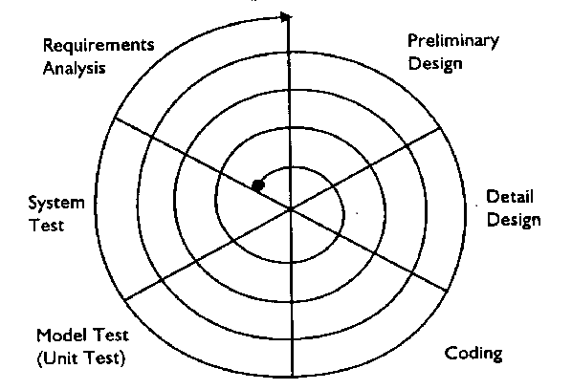

* 1. **Roles and Responsibilities**

Abhishek S:

HTML/CSS development, Report Documentation, Testing.

K Sidhartha Nambiar:

Coding Design, Frontend-Development, Backend data handling, testing.

Keshava Pranath K:

Design, Styling, Testing, Report Documentation.

Lakshya Sharma:

Genetic Algorithm, Testing, Report Documentation.

1. **LITERATURE SURVEY**
   1. **Introduction**

**ReactJS** is a popular open source front-end JavaScript library developed by Facebook, popular for the simplicity and ease of use with efficient working. In ReactJS, all the components govern their own state and manipulate UI according the state changes, making sure that only required part of the UI changes according the requirement.

**Redux** is a predictable state container for javascript apps. It helps to write application that behave consistently, run in different environments and are easy to test. The object is like a “model” except that there are no setters. This is so that different parts of the code can’t change the state arbitrarily, causing hard-to-reproduce bugs. To change something in the state, you need to dispatch an action. An action is a plain JavaScript object that describes what happened. Enforcing that every change is described as an action lets us have a clear understanding of what’s going on in the app. If something changed, we know why it changed. Actions are like breadcrumbs of what has happened. Finally, to tie state and actions together, we write a function called a reducer.

**Genetic algorithms** are a family of meta-heuristic search algorithms that are derived from the nature’s evolutionary techniques. Adjusting and optimizing of parameters is an important problem in practical applications. Because of the global random search capabilities of genetic algorithms, search of optima in a multi dimension search space can be found by randomly adjusting Pc and Pm. Experiments show that the method is reliable and effective. Under normal circumstances, any result has two components, the parameters and their respective weights. The genetic algorithm helps us to approximately find the optimal weight of each parameter which gives out the desired result with least error. Different with the traditional search algorithm, genetic algorithm is from a set of randomly generated solutions (called the initial solution) to begin the searching process. Population of each individual is a solution of the problem, known as chromosome. Chromosome is a string of symbols, such as a binary string. Iteration in the follow-up of these chromosomes continues to evolve as genetic, using fitness of each generation to measure the quality of the chromosome, to generate the next generation of chromosomes, called offspring. Generations of chromosomes from the previous generation are formatted by crossover or mutation computing. Choose the size according to the fitness part of future generations, out of some future generations, so as to maintain the population size is constant. Chromosome with high fitness is to be selected by high probability. In this way, after several generations, the algorithm converges to the best chromosome; it is likely the optimal solution or sub-optimal solution of the problem.

Distinguished from another kind of genetic algorithm is an improved genetic algorithm. In the standard genetic algorithm a new generation of hybrid populations is formatted after hybridized to the N pairs of mother. And outstanding choice of genetic algorithm is an individual, and the last individual to adapt to get the original value of the largest populations of the individual, such amendments to ensure the satisfaction of the population to adapt to sequence the monotonous reduction of value.

* 1. **Related works**
* The proposed system has existing variants across the globe, the most famous one being IEEE Journal/ Research Paper collection site [**https://www.ieee.org/**](https://www.ieee.org/)which focuses on the distribution of research papers amongst paid members of IEEE.
* One more variant for the idea is the platform that ranks competitive coders based on their problem solving skills, where its best example is Hackerrank website [**www.hackerrank.com/**](http://www.hackerrank.com/).
  1. **Conclusion of Survey**

The system being used here is a new of its kind. All the technology and tools used are very popular among the developers these days. The tools used for the front-end development of the project is extensively used in large area of web development today for better user experience.

1. **PROJECT MANAGEMENT PLAN**
   1. **Schedule of the project**

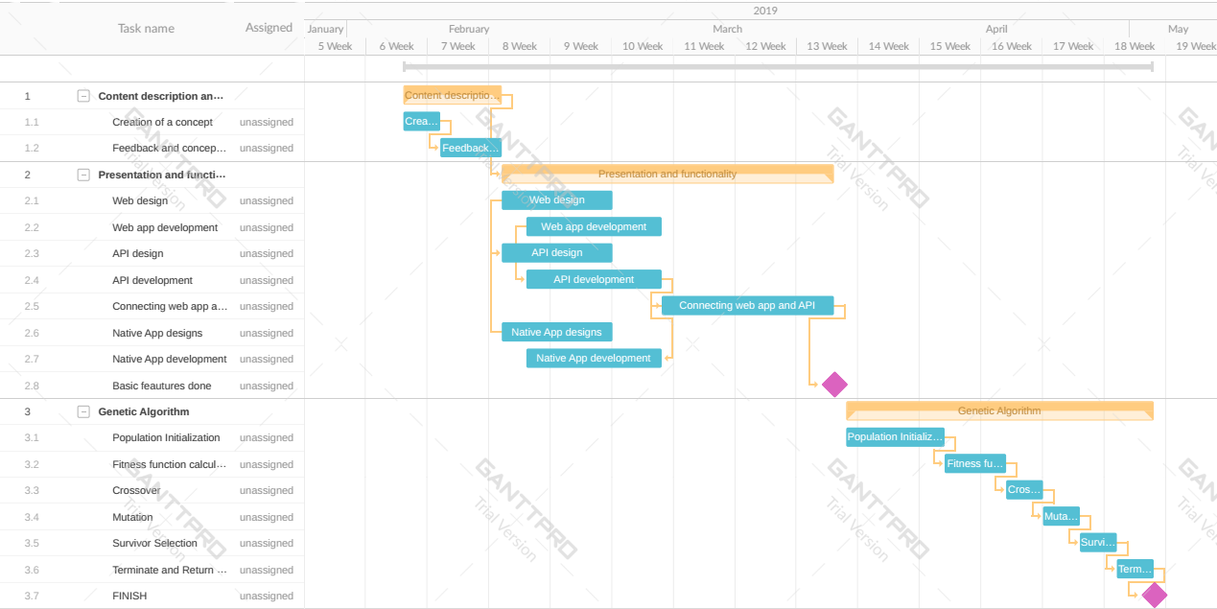

* 1. **Risk identification**

|  |  |  |  |
| --- | --- | --- | --- |
| **Risk** | **Probability** | **Impact** | **Exposure** |
| Incorrect Software  Functionality | Med | Med | Med |
| Instability of a network | High | High | High |
| Network latency | High | High | High |
| Complexity of  application | Med | High | High |
| Change in project  requirements | High | High | High |
| Technical Risk | Low | Low | Low |

|  |  |
| --- | --- |
| Risk | Mitigation Plan |
| Incorrect Software Functionality | * Organization analysis; Server analysis * User surveys * Prototyping |
| Instability of a network | * Creating a backup network that handles load when main server fails. |
| Network latency | * Using Bit-Torrent protocol for shortest routing approach. |
| Complexity of application | * Deploy persons with prior experience with domain |
| Change in project requirements | * Develop high scalable solution to reduce changes in code whenever there are additional requirements * Conduct a mid-stage review |
| Technical Risk | * Train Resources * Review Prototype with customers * Develop pair programming practices |

1. **SOFTWARE REQUIREMENT SPECIFICATION**
   1. **Product Overview**

TecRidge is a platform that enables developers to learn about the projects going on in their surroundings. Also, the developers can add their own ideas into the platform where they can come across the fellow developers, so that they can team up and hence make a better quality product of their idea. Also the developers can find for the suitable guide to guide them in their way to build the product. Also majority of the developers today are cut half their way because of lack of motivation in the area of their interest. Today technology has grown far way long, that all fields of developing can combine to produce great products.

* 1. **External Interface Requirement**
     1. **User Interfaces**

For User interaction, we have used React-js with Redux-js for a better and faster response. Also it gives better UI for easy usage by the user.

* + 1. **Hardware Interfaces**

The point of interface with the user is either Smartphone of the user or the laptop. On the other end for storage, we use Firebase DB at the back-end.

* + 1. **Software Interfaces**

We are using genetic algorithm for the grading of the projects uploaded in the platform. This is developed using python. Also the platform is web application, which works good in any browser that supports the JavaScript.

* 1. **Functional requirement**

Developers can give their skill set, which they are good at, so that any person can see the profile of the developer before taking them into the team in a project. Also guide can see the skill set of student and vice-versa before approaching.

Developer can search through the projects on the platform so that he/she can join any project on their point of interest. Also they can use this functionality to see the projects done in past to modify and upgrade it.

Also we are using **genetic algorithm** to grade the projects uploaded by the developers. This takes the input from the description given by the developer while uploading the project. The data given will be stored in Firebase. It is extracted and used for evaluation in GA and the result is stored back to the Firebase.

1. **Design**
   1. **Introduction**

Students gain practical experience only by indulging themselves into different projects and only through this they get introduced to new concepts of technologies whose practical knowledge can help them in their career. But the students with skills may not be having ideas and people with ideas may not be having skills to work upon those ideas. Majority of the developers today are cut half their way because of lack of motivation in the area of their interest. Today technology has grown far way long, that all fields of developing can combine to produce great products. Scope of this project can be up to a college but is also extensible to other colleges.

* 1. **Architecture Design**

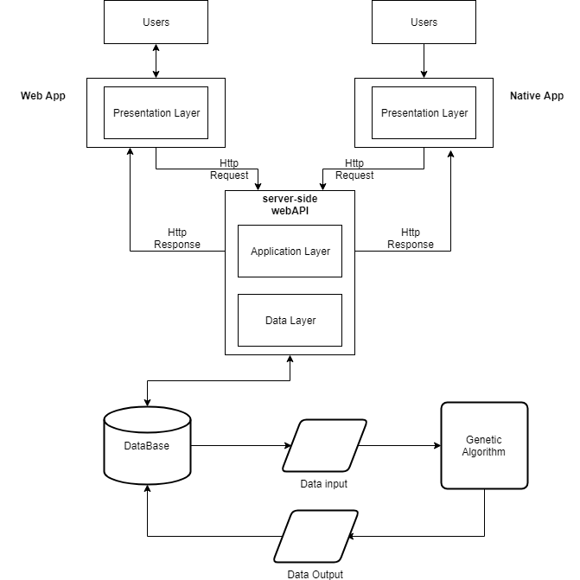

* 1. **Graphical User Interface**

Web app:

* Design a website that is extremely easy to navigate, looks good at both orientations and gives the barest minimum content mostly in text format. While this sounds simple, there is a lot of thought that needs to go in the UI and content development.
* Unlike print designs, where the viewing area of any design is fixed, web users can (and do) zoom in or out as they interact with a web page, changing the size of text and images. And, by the way, different browsing environments handle zoom differently.
  1. **Class Diagram and Classes**

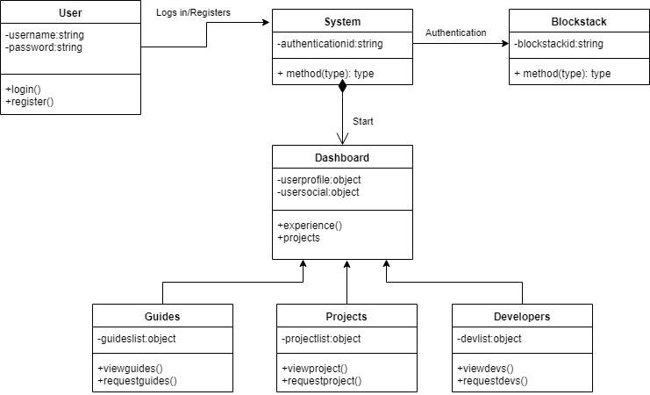

* 1. **Sequence Diagram**

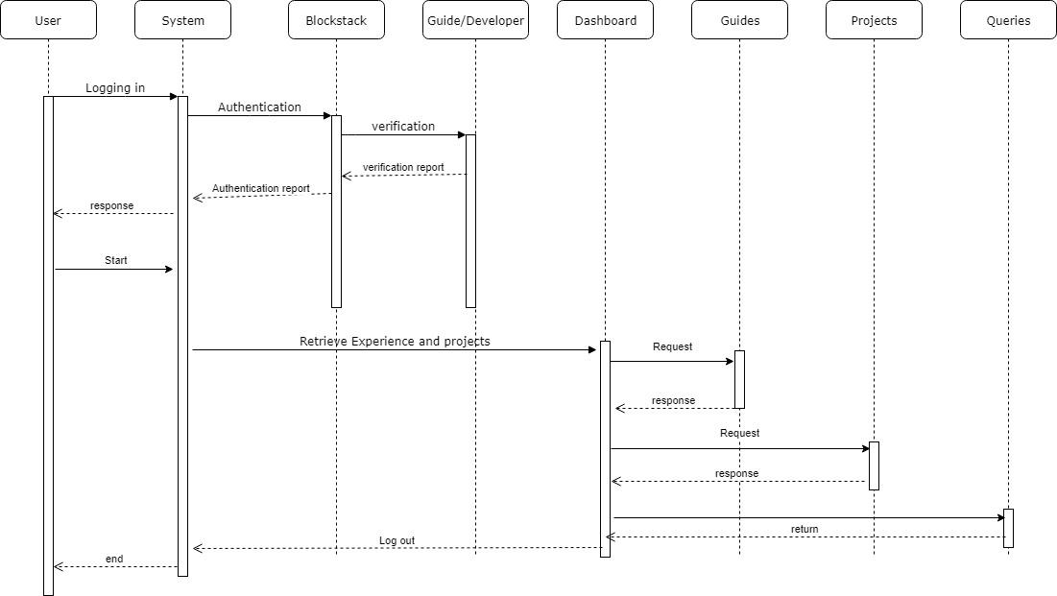

* 1. **Data flow diagram**

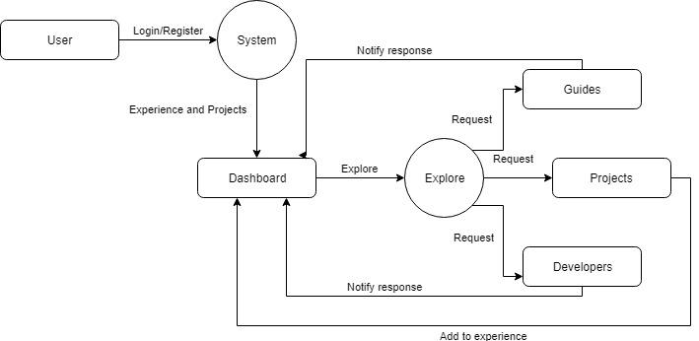

* 1. **Conclusion**

The design we use to implement the project very good and more productive for the web application kind of development done here. The Data flow and the classes ased for the data flow are efficient enough to give better user experience.

1. **IMPLEMENTATION**
   1. **Tools Introduction**

Visual Studio Code is a streamlined code editor with support for development operations like debugging, task running, and version control. It aims to provide just the tools a developer needs for a quick code-build-debug cycle and leaves more complex workflows to fuller featured IDEs. Also in-built git commands in the terminal for the tools helps the developer kee the project on cloud frequently. And thus helps in securing the projects from system failures. Also, it has a built-in terminal using which developer can run commands and execute the codes without switching the windows while developing.

Pycharm is a python IDE that helps developing codes and routines in python. It helps rely on the intelligent code completion, on-the-fly error checking and quick-fixes. It helps maintaining a neat and maintainable code that helps in boosting the code quality. It provides smart code completion, code inspection, it offers grate framework-specific support for modern web development framework.

* 1. **Technology Introduction**

**ReactJS** is a popular open source front-end JavaScript library developed by Facebook, popular for the simplicity and ease of use with efficient working. In ReactJS, all the components govern their own state and manipulate UI according the state changes, making sure that only required part of the UI changes according the requirement.

**Redux** is a predictable state container for javascript apps. It helps to write application that behave consistently, run in different environments and are easy to test. The object is like a “model” except that there are no setters. This is so that different parts of the code can’t change the state arbitrarily, causing hard-to-reproduce bugs. To change something in the state, you need to dispatch an action. An action is a plain JavaScript object that describes what happened. Enforcing that every change is described as an action lets us have a clear understanding of what’s going on in the app. If something changed, we know why it changed.

* 1. **Overall view of the project in terms of implementation**
* Design a website that is extremely easy to navigate, looks good at both orientations and gives the barest minimum content mostly in text format. While this sounds simple, there is a lot of thought that needs to go in the UI and content development.
* Unlike print designs, where the viewing area of any design is fixed, web users can (and do) zoom in or out as they interact with a web page, changing the size of text and images. And, by the way, different browsing environments handle zoom differently
* Restful API to provide a uniform interface which is stateless, cacheable. It is client-server layered system which supports code on demand.
* Genetic algorithm with high computational power and efficient fitness value to get appropriate results
* Native mobile app for the users to make easy with the accessing of the platform.
  1. **Explanation of Algorithm and how it is been implemented**

Genetic algorithms are a family of meta heuristic, search space algorithms that mimic nature's concepts of survival of the fittest, reproduction and mutation. A genetic algorithm has many parameters that distinguishes it from the other genetic algorithms; some of them are : probability of crossover, probability of mutations, crossover operator, mutation operator, termination conditions, population size, etc. The genetic algorithm we used has a probability of crossover 0.5, probability of mutation 0.01, arithmetic crossover operator with averager a = 0.4, random mutation operator and population size of 2500. The goal is to linearly combine separate, but interdependent parameters, so basically, optimize the set of weights they'll have to calculate an ELO of each project, which will help us to rank them in a just order. As of now this algorithm has 6 parameters to optimize, and room for many more. The algorithm finds optimal points in a multi-dimensional space (7 in our case) to get interesting or ‘hot’ zones, then, successive running of the algorithm accounts for the possible changes in the hot zones, thus making it a less maintenance needing AI algorithm. The individuals in each generation, tend to converge near these hot zones, so as to provide consistent and accurate results every time the algorithm runs.

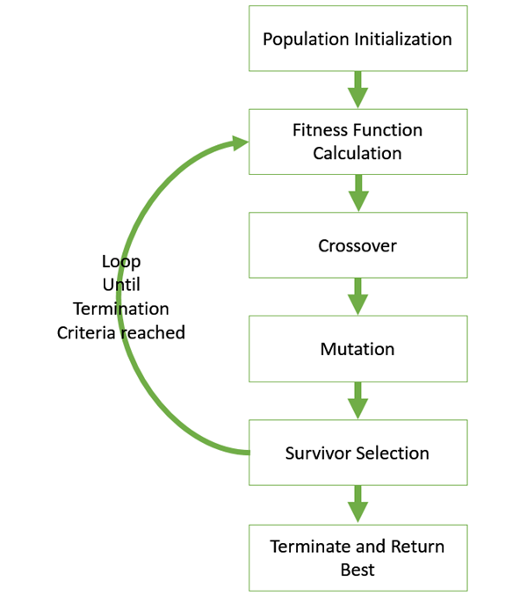

* 1. **Information about the implementation of Modules**

Front-end of the web-application is built on React an Redux, which works on the modules. This has modules that render components to the HTML page as and when required. The components are coded and stored as modules.

The backend of the webapp is stores and handled on firebase. It provides leveldb, no sql, key-value store which provides high level nesting and supports tree like structure.

* 1. **Conclusion**

Implementation of the webapp is basically designing the user interface to give a better using experience to the user.

Backend is being implemented to have a better data handling for the amount of data collected from the user.

Genetic Algorithm is implemented to give the good evaluation of the projects implemented by the user and hence enhance the productivity of the user.

1. **TESTING**
   1. **Introduction**

The design we build is modular and we can have unit testing for each modules. Each working UI can be tested individually. Also the GA we implemented can be tested individually. Hence we go with the unit testing and the following test cases are discussed below.

* 1. **Test cases**

**Initialization**

|  |  |  |  |
| --- | --- | --- | --- |
| **Sl. No.** | **Test Case** | **Expected Result** | **Test Result** |
| **1** | **Web page loading up** | **The web page loads up and asks user to enter login credentials** | **Successful** |

**Authentication**

|  |  |  |  |
| --- | --- | --- | --- |
| **Sl. No.** | **Test Case** | **Expected Result** | **Test Result** |
| **1** | **User profile retrieval** | **The login credentials are verified and the user profile is displayed** | **Successful** |

**Dashboard**

|  |  |  |  |
| --- | --- | --- | --- |
| **Sl. No.** | **Test Case** | **Expected Result** | **Test Result** |
| **1** | **Access to many features of the web site** | **Dashboard is displayed once user is logged in and many features are given to user** | **Successful** |

**Viewing guides, developers profile and project details**

|  |  |  |  |
| --- | --- | --- | --- |
| **Sl. No.** | **Test Case** | **Expected Result** | **Test Result** |
| **1** | **User views guides, other developers and projects to see to know about them.** | **User gets to know the guide, developer and projects and sends a request** | **Successful** |

1. **CONCLUSION AND SCOPE FOR FUTURE WORK**

The project is focused on providing the platform for the welfare of the developers. This main focus is to help the developers to have a good carrier developing interesting and more helpful solution solving the problems of the real world.

There are a lot of extension which can be done the idea. The first extension possible is to have a group for each clan of developer and enhance their productivity by providing challenges to solve and help the real world situation.

1. **REFERENCES**
2. Elaine Rich, Kevin Knight, Shivashankar B Nair: Artificial Intelligence, 3rd edition, Tata McGraw Hill, 2011 (Genetic Algorithms)
3. Web Application Design and Implementation: Apache 2, PHP5, MySQL, JavaScript, and Linux/UNIX Steven A. Gabarro, December 2006, ©2007, Wiley-IEEE Computer Society Press.(JavaScript)
4. Nate Murray, Felipe Coury, Ari Lerner and Carlos Taborda, “ng-book, The Complete Book on Angular 4” September 2016 3. KrasimirTsonev, “Node.js by Example Paperback”, May 2015. (Nodejs)
5. Tutorial Point - Simply Easy Learnig for Genetic Algorithm (<https://www.tutorialspoint.com/genetic_algorithms/>)
6. Firebase docs- (https://firebase.google.com/docs/web/setup)
7. React-Native(<https://facebook.github.io/react-native/>)
8. Reactjs-( https://reactjs.org/)
9. Redux-( <https://redux.js.org/>)